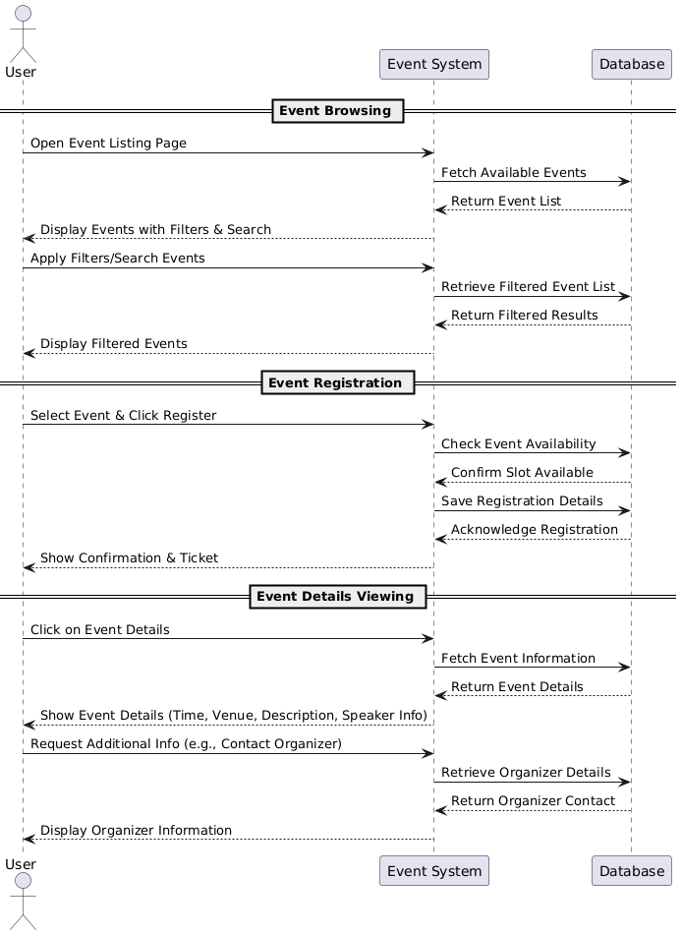

**Database:**

**Functional Requirements (FRs)**

**Event Browsing**

* **FR1:** The system shall allow users to browse a list of available events.
* **FR2:** The system shall provide filtering options (e.g., by date, location, category).
* **FR3:** The system shall allow users to search for events by title or keyword.

**Event Registration**

* **FR4:** The system shall allow users to register for an event.
* **FR5:** The system shall check event availability before confirming registration**.**
* **FR6:** The system shall store the user’s registration details in the database.
* **FR7:** The system shall display a confirmation message after successful registration.
* **FR8:** The system shall allow users to cancel their event registration.

**Event Details Viewing**

* **FR9:** The system shall allow users to view event details (title, time, venue, description).

**Non-Functional Requirements (NFRs)**

**Performance Requirements**

* **NFR1:** The system should handle at least 500 concurrent users without performance degradation.
* **NFR2:** Event search results should be displayed within 2 seconds.

**Security Requirements**

* **NFR3**: User data (e.g., registration details) shall be stored securely using encryption.
* **NFR4:** Only authenticated users should be able to register for events.
* **NFR5:** The system should prevent duplicate registrations for the same event.